QUT SWHS
Bachelor of Human Services Final Placement
Field Education Learning Plan & Assessment Report (LP&AR)

Student Name: |  | Field Educator Name:
Agency Name: |  | Date:
Semester: |  | Placement hrs to complete: | 350
Unit Code: | SWB314 | Placement hours completed so far (mid-placement review)

Mid-Placement Checklist (to be completed by the agency supervisor) Please tick one
The student and agency supervisor believe that the student has the capacity to pass placement on the final assessment.

A plan has been developed to support the student’s identified needs. Strategies have been documented in the relevant sections of this report

Learning Areas, Evidence and Rating

This document will contain all of your field education evidence and record of your progress of achievement during your first placement. It is divided into four sections:

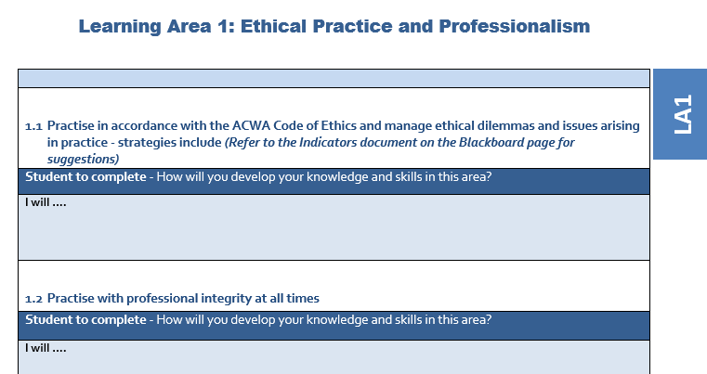
- Learning Areas. There are five Learning Areas. You will need to explain how you will demonstrate work to achieve each of these. This is something you should do with your field educator/supervisor by week 3. You will do this once only, at the beginning of your placement.

- Evidence of Capability. For each Learning Area you will need to discuss with your field supervisor evidence of your learning as it relates to each of the five Key Learning Areas. There are some questions asked to facilitate this.

- Rating. For each Learning Area you and your field educator/supervisor will jointly rate your own performance. It is expected that students on first placement will achieve at least ‘Beginning Level competency’ in each of the learning areas to pass the placement. For second placement, it is expected that students demonstrate the ‘Graduate Level Competency’ in each of the learning areas in order to pass the placement.

Rating | Explanation
Learning Not Met (LNM) | The Student has not met the requirements of this Learning Area. Please include an explanation about why the standard was not met, an example of what strategies have been tried to reach competency in this Learning Area, and if Mid-Placement- what further strategies will be adopted during the remainder of the placement.
Beginning Level (BL) | The Student has demonstrated a level of competency that would be expected for a beginning practitioner. There has been demonstration of understanding of the Practice Standards within the Learning Area and with close guidance and supervision it is expected the student will progress to Graduate Level for this Learning Area. This rating is a PASS MARK for First Placement.
Graduate Competency (GC) | The Student has demonstrated a level of competency indicating they can perform independently, demonstrate adaptability and critical thinking for this Learning Area. This rating is required as a PASS MARK for Second Placement.
A Mid-Placement Assessment Report is to be completed between the student and the Agency Supervisor at approximately midpoint of the placement to assess initial student progress.
- The student will critically reflect on their progress against the six Learning Areas and record ratings and comments against each of the Learning Areas. Comments will include practical examples demonstrating learning against the Learning Area criteria.
- The Agency Supervisor will then also provide their comments and ratings against each of the Learning Areas. Comments will also reflect practical examples of how the student has demonstrated learning in each Learning Area.
If any concerns or issues are identified during this process, it is expected that the student and the Agency Supervisor will identify within the comments what additional support measures are being implemented to ensure the student gains the skills needed to achieve competency in each Learning Area. Any issues identified during any part of placement need to be identified to the University Liaison Visitor as soon as possible.

The Final Placement Assessment Report is undertaken by a similar process between the student and the Agency Supervisor within the final weeks of placement. This will be forwarded to the Liaison Visitor within 2 weeks of the completion of placement.

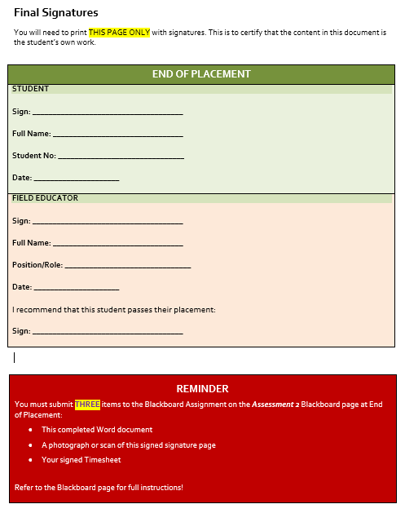
- Signature Page. At the end of the document, both you and your field educator will need to print and sign this page and then scan and upload onto Blackboard.

Learning Area 1: Ethical Practice and Professionalism

LA1

Practice in accordance with the ACWA Code of Ethics and manage ethical dilemmas and issues arising in practice.
Student to complete – What tasks/activities will you undertake to develop your knowledge and skills in this area?
I will ….

Practice with professional integrity at all times
Student to complete - What tasks/activities will you undertake to develop your knowledge and skills in this area?
I will ….

  - Keep and maintain information in accordance with ethical principles and relevant legislation
Student to complete - What tasks/activities will you undertake to develop your knowledge and skills in this area?
I will ….

Evidence of Capability for Learning Area 1

ETHICAL PRACTICE AND PROFESSIONALISM

EVIDENCE to support ratings

Student/Agency supervisor
Examples
- Documenting an interaction where the student identified inequalities or injustices and advocated for change. How was this done? What was the outcome?
- Documenting a time when the student has raised an ethical issue or dilemma and attempted to seek a solution- How was this done? What was the outcome?
- Demonstrating how the student has critically reflected on their personal and professional ethics and values and how they influence practice.
If issues are identified, please document what will be tried / has been tried to achieve competency in this Learning area.
Mid-placement

Final Placement

Ratings
Student |  | Agency Supervisor
Mid | End | Mid | End

Learning Area 2: Provision of Service and Support
LA2

2.1 Ability to base professional practice on relevant human service theories, incorporating principles of human rights and access to appropriate services and support. Professional practice includes direct practice, research, project or policy related work.
Student to complete – What tasks/activities will you undertake to develop your knowledge and skills in this area?
I will ….

2.2 Ability to demonstrate effective delivery of services that meet the needs of the service users (individual, groups or communities), in either direct practice, research or policy contexts, including evaluation of outcomes.
Student to complete - What tasks/activities will you undertake to develop your knowledge and skills in this area?
I will ….

2.3 Understand the context of placement, including relevant policies and procedures, legislation and higher level systemic influences
Student to complete – What tasks/activities will you undertake to develop your knowledge and skills in this area?
I will ….

Evidence of Capability for Learning Area 2

PROVISION OF SERVICE AND SUPPORT

EVIDENCE to support ratings

Student/Agency supervisor
Examples
- Student can articulate how service users provide feedback/make complaints
- Student is able to articulate at least one human service theory (based on human rights) that they have seen as influencing practice at the agency
- Student articulates how power differentials between service users and service providers present at the agency
- Student identifies gaps or issues in service delivery, if any.
If issues are identified, please document what will be tried / has been tried to achieve competency in this Learning area.
Mid-Placement

Final Placement

Ratings
Student |  | Agency Supervisor
Mid | End | Mid | End

Learning Area 3: Interpersonal communication skills

LA3

3.1 Effectively and respectfully communicate the details and nature of the service offered to people and their user rights
Student to complete - What tasks/activities will you undertake to develop your knowledge and skills in this area?
I will ….

3.2 Build effective relationships and work collaboratively with others
Student to complete - What tasks/activities will you undertake to develop your knowledge and skills in this area?
I will ….

I will ….

  - Use information technology to communicate and provide services as appropriate. Record and manage information appropriately
Student to complete - What tasks/activities will you undertake to develop your knowledge and skills in this area?
I will ….

I will ….

Evidence of Capability for Learning Area 3

INTERPERSONAL COMMUNICATION SKILLS

EVIDENCE to support rating

Student/Agency supervisor
Examples
- How has the student demonstrated the skills required to communicate and work effectively as a human service worker?
- Student can articulate service users rights
- How has the student demonstrated an understanding of the accountability and responsibility for human workers in collecting and keeping information in the course of their work?
- Student completes a process recording and discusses with supervisor
If issues are identified, please document what will be tried / has been tried to achieve competency in this Learning area.
Mid-Placement

Final Placement

Ratings
Student |  | Agency Supervisor
Mid | End | Mid | End

Learning Area 4: Ethical understanding and practice in working with diversity

LA4
4.1 Demonstrate critical understanding, respect and inclusivity in working with diversity in all forms
Student to complete - What tasks/activities will you undertake to develop your knowledge and skills in this area?
I will ….

4.2 Working respectfully and promoting the rights of Aboriginal and Torres Strait Islander peoples and their cultures
Student to complete - What tasks/activities will you undertake to develop your knowledge and skills in this area?
I will ….

Evidence of Capability for Learning Area 4

ETHICAL UNDERSTANDING AND PRACTICE IN WORKING WITH DIVERSITY

EVIDENCE to support rating

Student/Agency supervisor
Examples
- How the student has demonstrated understanding and knowledge of cultural diversity in order to work in a culturally responsive and inclusive way.
- Documenting a scenario where the student has needed to draw on their understanding of culturally responsive and inclusive practice to manage interactions in the workplace or with clients, during their placement

If issues are identified, please document what will be tried / has been tried to achieve competency in this Learning area.
Mid-Placement

Final Placement

Ratings
Student |  | Agency Supervisor
Mid | End | Mid | End

Learning Area 5: Supervision and commitment to professional development

5.1 Actively engage in professional supervision to build knowledge and critical reflective skills
Student to complete - What tasks/activities will you undertake to develop your knowledge and skills in this area?
I will ….

5.2 Engage in continuous self-learning and professional development
Student to complete - What tasks/activities will you undertake to develop your knowledge and skills in this area?
I will ….

Evidence of Capability for Learning Area 5

SUPERVISION AND COMMITMENT TO PROFESSIONAL DEVELOPMENT

EVIDENCE for ratings

Student/Agency supervisor
Examples
- Demonstrating how the student has maintained professional / personal boundaries during placement
- Describing how the student has represented their human services role in a professional context outside the agency
- Student has taken responsibility for actions and decisions
- Student records weekly diary reflections on practice experiences and discusses with supervisor

If issues are identified, please document what will be tried / has been tried to achieve competency in this Learning area.
Mid-Placement

Final Placement

Ratings
Student |  | Agency Supervisor
Mid | End | Mid | End

Comments and feedback

The following section is designed to provide an overall perspective on the student’s learning on placement to date, as well as advice around further professional development and growth.

End of PLACEMENT

Share a list of the student’s strengths to date (jointly completed by field educator/s and student)

Share any suggestions for future development for the student (jointly completed by field educators/ and student)

Field Educator/s’ comments | Student’s comments
Signature: ___________________________________  (Field Educator) | Date: __________________________
Signature: ___________________________________  (Student) | Date: __________________________

Notes:
- Students and Field Educators are advised to keep a signed copy of this report for future reference before the student submits this document to the Unit’s Blackboard site. If you have any questions regarding this document, please email: health.wils@qut.edu.au.

Final Signatures

You will need to print THIS PAGE ONLY with signatures. This is to certify that the content in this document is the student’s own work.

END OF PLACEMENT
STUDENT

Sign: _____________________________________

Full Name: ________________________________

Student No: _______________________________

Date: _____________________

FIELD EDUCATOR

Sign: _____________________________________

Full Name: ________________________________

Position/Role: _______________________________

Date: _____________________

I recommend that this student passes their placement:
Sign: _____________________________________

REMINDER
You must submit THREE items to the Blackboard Assignment on the Assessment 2 Blackboard page at End of Placement:
- This completed Word document
- A photograph or scan of this signed signature page
- Your signed Timesheet

Refer to the Blackboard page for full instructions!

