QUT SWHS
Bachelor/Masters of Social Work (Q) Final Placement
Field Education Learning Plan & Assessment Report (LP&AR)

Student Name: |  | Field Educator Name:
Agency Name: |  | Social Work Field Educator (External)  (if applicable)
Semester: |  | Date:
Unit Code: |  | Placement hrs. to complete:

Student’s Overall Learning Plan Goals for Placement

Consider what you would like to personally learn in practice. These goals can be things like time management, achieving placement/university/life balance, individual reflection skills or even building confidence. Discuss these with your field educators as part of your overall learning plan and strategy.

1
2
3
4
5

Learning Areas, Evidence and Rating

This document will contain all of your field education evidence and record of your progress of achievement during your first placement. It is divided into four sections:

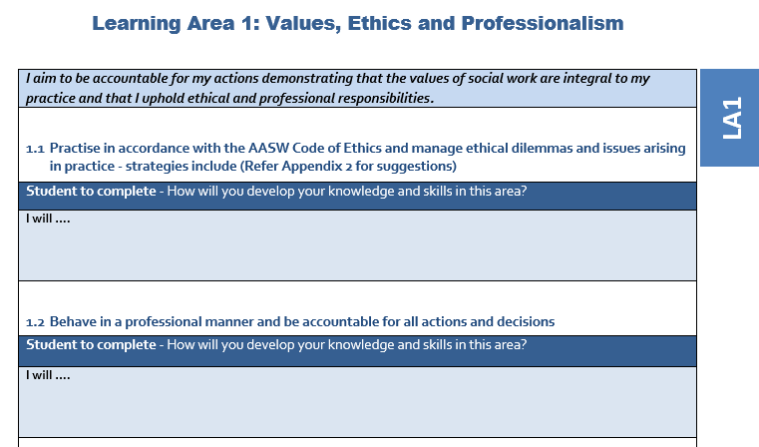
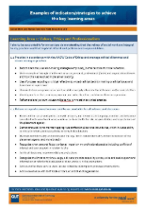
- Learning Areas. There are six Learning Areas. You will need to explain how you will demonstrate work to achieve each of these. This is something you should do with your field educator/supervisor by week 3. You will do this once only, at the beginning of your placement.
For details of the Indicators for each learning area please see the Indicators document at the bottom of the Blackboard page.

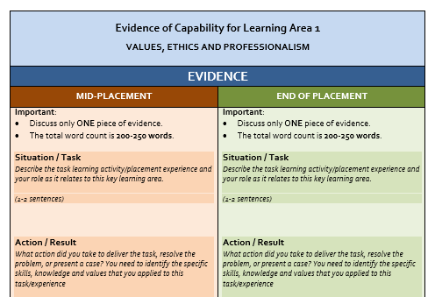
- Evidence of Capability. For each Learning Area you will need to provide brief evidence of your learning as it relates to each of the six Key Learning Areas. You will use the template provided to structure your reflection of your learning.
  - The orange section is for your Mid-Placement
  - The green section is for your End of Placement.

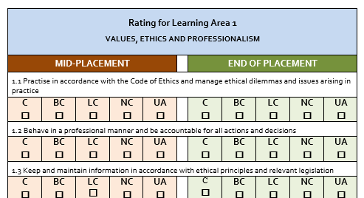
- Rating. For each Learning Area you and your field educator/supervisor will jointly rate your own performance.
  - The orange section is for your Mid-Placement
  - The green section is for your End of Placement.
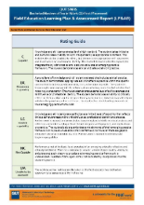
For details of rating scale please see please see the Rating Guide document at the bottom of the Blackboard page.

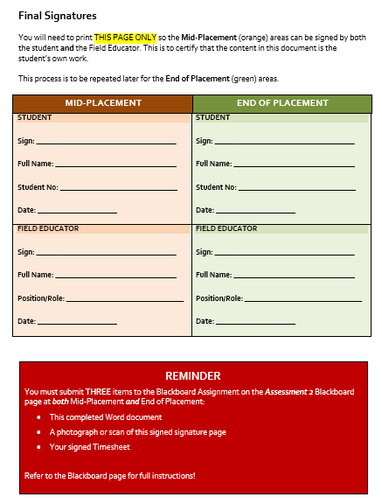
- Signature Page. At the end of the document both you and your field educator will need to print and sign this page and then scan and upload onto Blackboard.
  - The orange section is for your Mid-Placement
  - The green section is for your End of Placement.

Learning Area 1: Values, Ethics and Professionalism

I aim to be accountable for my actions demonstrating that the values of social work are integral to my practice and that I uphold ethical and professional responsibilities.
LA1

Practise in accordance with the AASW Code of Ethics and manage ethical dilemmas and issues arising in practice - strategies include (Refer to the Indicators document on the Blackboard page for suggestions)
Student to complete - How will you develop your knowledge and skills in this area?
I will ….

Behave in a professional manner and be accountable for all actions and decisions
Student to complete - How will you develop your knowledge and skills in this area?
I will ….

  - Keep and maintain information in accordance with ethical principles and relevant legislation
Student to complete - How will you develop your knowledge and skills in this area?
I will ….

Evidence of Capability for Learning Area 1

VALUES, ETHICS AND PROFESSIONALISM

EVIDENCE
MID-PLACEMENT | END OF PLACEMENT
Important:  - Discuss only ONE piece of evidence.  - The total word count is 200-250 words.  Situation / Task  Describe the task learning activity/placement experience and your role as it relates to this key learning area.  (1-2 sentences)  Action / Result  What action did you take to deliver the task, resolve the issue, address the need  What was the outcome in this situation?  (1-2 sentences)  Learning  Upon reflection, what did you learn about social work from this experience in relation to the key learning area? You may want to consider questions such as:  - What would you do differently next time?  - How could you apply this learning to other situations?  - How does this inform your emerging practice framework?  (The detail should be in this section and linked back to this key learning area.) | Important:  - Discuss only ONE piece of evidence.  - The total word count is 200-250 words.  Situation / Task  Describe the task learning activity/placement experience and your role as it relates to this key learning area.  (1-2 sentences)  Action / Result  What action did you take to deliver the task, resolve the issue, address the need  What was the outcome in this situation?  (1-2 sentences)  Learning  Upon reflection, what did you learn about social work from this experience in relation to the key learning area? You may want to consider questions such as:  - What would you do differently next time?  - How could you apply this learning to other situations?  - How does this inform your emerging practice framework?  (The detail should be in this section and linked back to learning in this key learning area.)

Rating for Learning Area 1

VALUES, ETHICS AND PROFESSIONALISM

MID-PLACEMENT |  |  |  |  |  |  | END OF PLACEMENT

1.1 Practise in accordance with the Code of Ethics and manage ethical dilemmas and issues arising in practice
C  ☐ | BC  ☐ | LC  ☐ | NC  ☐ | UA  ☐ |  |  | HC  ☐ | C  ☐ | BC  ☐ | LC  ☐ | NC  ☐ | UA  ☐

1.2 Behave in a professional manner and be accountable for all actions and decisions
C  ☐ | BC  ☐ | LC  ☐ | NC  ☐ | UA  ☐ |  |  | HC  ☐ | C  ☐ | BC  ☐ | LC  ☐ | NC  ☐ | UA  ☐

1.3 Keep and maintain information in accordance with ethical principles and relevant legislation
C  ☐ | BC  ☐ | LC  ☐ | NC  ☐ | UA  ☐ |  |  | HC  ☐ | C  ☐ | BC  ☐ | LC  ☐ | NC  ☐ | UA  ☐
OVERALL RATING LEARNING AREA 1
C  ☐ | BC  ☐ | LC  ☐ | NC  ☐ | UA  ☐ |  |  | HC  ☐ | C  ☐ | BC  ☐ | LC  ☐ | NC  ☐ | UA  ☐
Feedback to support further rating development
Please provide additional detail or comments regarding the rating recommended and any detail to support further development.
Field Educator/s’ Comments |  |  |  |  |  | Field Educator/s’ Comments
Student’s Comment’s |  |  |  |  |  | Student’s Comment’s

Learning Area 2: Culturally and Inclusive Practice
LA2

I aim to demonstrate understanding and knowledge of cultural diversity in order to work in a culturally responsive and inclusive way.

2.1 Work respectfully and inclusively with cultural difference and diversity
Student to complete – How will you develop your knowledge and skills in this area?
I will ….

2.2 Respect, strive to understand and promote the rights of Aboriginal and Torres Strait Islander peoples and their cultures
Student to complete - How will you develop your knowledge and skills in this area?
I will ….

Evidence of Capability for Learning Area 2

CULTURALLY AND INCLUSIVE PRACTICE

EVIDENCE
MID-PLACEMENT | END OF PLACEMENT
Important:  - Discuss only ONE piece of evidence.  - The total word count is 200-250 words.  Situation / Task  Describe the task learning activity/placement experience and your role as it relates to this key learning area.  (1-2 sentences)  Action / Result  What action did you take to deliver the task, resolve the issue, address the need  What was the outcome in this situation?  (1-2 sentences)  Learning  Upon reflection, what did you learn about social work from this experience in relation to the key learning area? You may want to consider questions such as:  - What would you do differently next time?  - How could you apply this learning to other situations?  - How does this inform your emerging practice framework?  (The detail should be in this section and linked back to learning in this key learning area.) | Important:  - Discuss only ONE piece of evidence.  - The total word count is 200-250 words.  Situation / Task  Describe the task learning activity/placement experience and your role as it relates to this key learning area.  (1-2 sentences)  Action / Result  What action did you take to deliver the task, resolve the issue, address the need  What was the outcome in this situation?  (1-2 sentences)  Learning  Upon reflection, what did you learn about social work from this experience in relation to the key learning area? You may want to consider questions such as:  - What would you do differently next time?  - How could you apply this learning to other situations?  - How does this inform your emerging practice framework?  (The detail should be in this section and linked back to learning in this key learning area.)

Rating for Learning Area 2

CULTURALLY AND INCLUSIVE PRACTICE

MID-PLACEMENT |  |  |  |  |  |  | END OF PLACEMENT

2.1 Work respectfully and inclusively with cultural difference and diversity
C  ☐ | BC  ☐ | LC  ☐ | NC  ☐ | UA  ☐ |  |  | HC  ☐ | C  ☐ | BC  ☐ | LC  ☐ | NC  ☐ | UA  ☐

2.2 Respect, strive to understand and promote the rights of Aboriginal and Torres Strait Islander peoples and their cultures
C  ☐ | BC  ☐ | LC  ☐ | NC  ☐ | UA  ☐ |  |  | HC  ☐ | C  ☐ | BC  ☐ | LC  ☐ | NC  ☐ | UA  ☐
OVERALL RATING LEARNING AREA 2
C  ☐ | BC  ☐ | LC  ☐ | NC  ☐ | UA  ☐ |  |  | HC  ☐ | C  ☐ | BC  ☐ | LC  ☐ | NC  ☐ | UA  ☐
Feedback to support further rating development
Please provide additional detail or comments regarding the rating recommended and any detail to support further development.
Field Educator/s’ Comments |  |  |  |  |  | Field Educator/s’ Comments
Student’s Comment’s |  |  |  |  |  | Student’s Comment’s

Learning Area 3: Develop and Apply Knowledge for Practice

I aim to demonstrate that I am acquiring the required knowledge for effective and safe ethical practice.
LA3

3.1 Understand higher level systemic influences on people with respect to area of practice
Student to complete - How will you develop your knowledge and skills in this area?
I will ….

3.2 Understand and articulate how and when social work and other relevant theories and concepts inform practice
Student to complete - How will you develop your knowledge and skills in this area?
I will ….

3.3 Understand the roles of research and evaluation in obtaining and generating new knowledge for practice
Student to complete - How will you develop your knowledge and skills in this area?
I will ….

Evidence of Capability for Learning Area 3

DEVELOP AND APPLY KNOWLEDGE FOR PRACTICE

EVIDENCE
MID-PLACEMENT | END OF PLACEMENT
Important:  - Discuss only ONE piece of evidence.  - The total word count is 200-250 words.  Situation / Task  Describe the task learning activity/placement experience and your role as it relates to this key learning area.  (1-2 sentences)  Action / Result  What action did you take to deliver the task, resolve the issue, address the need  What was the outcome in this situation?  (1-2 sentences)  Learning  Upon reflection, what did you learn about social work from this experience in relation to the key learning area? You may want to consider questions such as:  - What would you do differently next time?  - How could you apply this learning to other situations?  - How does this inform your emerging practice framework?  (The detail should be in this section and linked back to learning in this key learning area.) | Important:  - Discuss only ONE piece of evidence.  - The total word count is 200-250 words.  Situation / Task  Describe the task learning activity/placement experience and your role as it relates to this key learning area.  (1-2 sentences)  Action / Result  What action did you take to deliver the task, resolve the issue, address the need  What was the outcome in this situation?  (1-2 sentences)  Learning  Upon reflection, what did you learn about social work from this experience in relation to the key learning area? You may want to consider questions such as:  - What would you do differently next time?  - How could you apply this learning to other situations?  - How does this inform your emerging practice framework?  (The detail should be in this section and linked back to learning in this key learning area.)

Rating for Learning Area 3

DEVELOP AND APPLY KNOWLEDGE FOR PRACTICE

MID-PLACEMENT |  |  |  |  |  |  | END OF PLACEMENT

3.1 Understand higher level systemic influences on people with respect to area of practice
C  ☐ | BC  ☐ | LC  ☐ | NC  ☐ | UA  ☐ |  |  | HC  ☐ | C  ☐ | BC  ☐ | LC  ☐ | NC  ☐ | UA  ☐

3.2 Understand and articulate how and when social work and other relevant theories and concepts inform practice
C  ☐ | BC  ☐ | LC  ☐ | NC  ☐ | UA  ☐ |  |  | HC  ☐ | C  ☐ | BC  ☐ | LC  ☐ | NC  ☐ | UA  ☐

3.3 Understand the roles of research and evaluation in obtaining and generating new knowledge for practice
C  ☐ | BC  ☐ | LC  ☐ | NC  ☐ | UA  ☐ |  |  | HC  ☐ | C  ☐ | BC  ☐ | LC  ☐ | NC  ☐ | UA  ☐
OVERALL RATING LEARNING AREA 3
C  ☐ | BC  ☐ | LC  ☐ | NC  ☐ | UA  ☐ |  |  | HC  ☐ | C  ☐ | BC  ☐ | LC  ☐ | NC  ☐ | UA  ☐
Feedback to support further rating development
Please provide additional detail or comments regarding the rating recommended and any detail to support further development.
Field Educator/s’ Comments |  |  |  |  |  | Field Educator/s’ Comments
Student’s Comment’s |  |  |  |  |  | Student’s Comment’s

Learning Area 4: Application of Skills for Practice

I aim to demonstrate effective social work skills as required to implement knowledge into practice.
LA4

4.1 Conduct assessment and analysis of individual, group or community needs to inform the service being offered
Student to complete - How will you develop your knowledge and skills in this area?
I will ….

4.2 Uses a range of specific social work methods and techniques appropriate to area of practice
Student to complete - How will you develop your knowledge and skills in this area?
I will ….

4.3 Apply critical and reflective thinking to practice
Student to complete - How will you develop your knowledge and skills in this area?
I will ….

Evidence of Capability for Learning Area 4

APPLICATION OF SKILLS FOR PRACTICE

EVIDENCE
MID-PLACEMENT | END OF PLACEMENT
Important:  - Discuss only ONE piece of evidence.  - The total word count is 200-250 words.  Situation / Task  Describe the task learning activity/placement experience and your role as it relates to this key learning area.  (1-2 sentences)  Action / Result  What action did you take to deliver the task, resolve the issue, address the need  What was the outcome in this situation?  (1-2 sentences)  Learning  Upon reflection, what did you learn about social work from this experience in relation to the key learning area? You may want to consider questions such as:  - What would you do differently next time?  - How could you apply this learning to other situations?  - How does this inform your emerging practice framework?  (The detail should be in this section and linked back to learning in this key learning area.) | Important:  - Discuss only ONE piece of evidence.  - The total word count is 200-250 words.  Situation / Task  Describe the task learning activity/placement experience and your role as it relates to this key learning area.  (1-2 sentences)  Action / Result  What action did you take to deliver the task, resolve the issue, address the need  What was the outcome in this situation?  (1-2 sentences)  Learning  Upon reflection, what did you learn about social work from this experience in relation to the key learning area? You may want to consider questions such as:  - What would you do differently next time?  - How could you apply this learning to other situations?  - How does this inform your emerging practice framework?  (The detail should be in this section and linked back to learning in this key learning area.)

Rating for Learning Area 4

APPLICATION OF SKILLS FOR PRACTICE

MID-PLACEMENT |  |  |  |  |  |  | END OF PLACEMENT

4.1 Conduct assessment and analysis of individual, group or community needs to inform the service being offered
C  ☐ | BC  ☐ | LC  ☐ | NC  ☐ | UA  ☐ |  |  | HC  ☐ | C  ☐ | BC  ☐ | LC  ☐ | NC  ☐ | UA  ☐

4.2 Uses a range of specific social work methods and techniques appropriate to area of practice
C  ☐ | BC  ☐ | LC  ☐ | NC  ☐ | UA  ☐ |  |  | HC  ☐ | C  ☐ | BC  ☐ | LC  ☐ | NC  ☐ | UA  ☐

4.3 Apply critical and reflective thinking to practice
C  ☐ | BC  ☐ | LC  ☐ | NC  ☐ | UA  ☐ |  |  | HC  ☐ | C  ☐ | BC  ☐ | LC  ☐ | NC  ☐ | UA  ☐
OVERALL RATING LEARNING AREA 4
C  ☐ | BC  ☐ | LC  ☐ | NC  ☐ | UA  ☐ |  |  | HC  ☐ | C  ☐ | BC  ☐ | LC  ☐ | NC  ☐ | UA  ☐
Feedback to support further rating development
Please provide additional detail or comments regarding the rating recommended and any detail to support further development.
Field Educator/s’ Comments |  |  |  |  |  | Field Educator/s’ Comments
Student’s Comment’s |  |  |  |  |  | Student’s Comment’s

Learning Area 5: Communication and Interpersonal Skills

I aim to demonstrate the skills required to communicate and work effectively with others.
LA5

5.1 Effectively communicate with a diverse range of people
Student to complete - How will you develop your knowledge and skills in this area?
I will ….

5.2 Build effective relationships and work collaboratively with others
Student to complete - How will you develop your knowledge and skills in this area?
I will ….

5.3 Ethically use information technology to communicate and provide services as appropriate
Student to complete - How will you develop your knowledge and skills in this area?
I will ….

Evidence of Capability for Learning Area 5

COMMUNICATION AND INTERPERSONAL SKILLS

EVIDENCE
MID-PLACEMENT | END OF PLACEMENT
Important:  - Discuss only ONE piece of evidence.  - The total word count is 200-250 words.  Situation / Task  Describe the task learning activity/placement experience and your role as it relates to this key learning area.  (1-2 sentences)  Action / Result  What action did you take to deliver the task, resolve the issue, address the need  What was the outcome in this situation?  (1-2 sentences)  Learning  Upon reflection, what did you learn about social work from this experience in relation to the key learning area? You may want to consider questions such as:  - What would you do differently next time?  - How could you apply this learning to other situations?  - How does this inform your emerging practice framework?  (The detail should be in this section and linked back to learning in this key learning area.) | Important:  - Discuss only ONE piece of evidence.  - The total word count is 200-250 words.  Situation / Task  Describe the task learning activity/placement experience and your role as it relates to this key learning area.  (1-2 sentences)  Action / Result  What action did you take to deliver the task, resolve the issue, address the need  What was the outcome in this situation?  (1-2 sentences)  Learning  Upon reflection, what did you learn about social work from this experience in relation to the key learning area? You may want to consider questions such as:  - What would you do differently next time?  - How could you apply this learning to other situations?  - How does this inform your emerging practice framework?  (The detail should be in this section and linked back to learning in this key learning area.)

Rating for Learning Area 5

COMMUNICATION AND INTERPERSONAL SKILLS

MID-PLACEMENT |  |  |  |  |  |  | END OF PLACEMENT

5.1 Effectively communicate with a diverse range of people
C  ☐ | BC  ☐ | LC  ☐ | NC  ☐ | UA  ☐ |  |  | HC  ☐ | C  ☐ | BC  ☐ | LC  ☐ | NC  ☐ | UA  ☐

5.2 Build effective relationships and work collaboratively with others
C  ☐ | BC  ☐ | LC  ☐ | NC  ☐ | UA  ☐ |  |  | HC  ☐ | C  ☐ | BC  ☐ | LC  ☐ | NC  ☐ | UA  ☐

5.3 Ethically use information technology to communicate and provide services as appropriate
C  ☐ | BC  ☐ | LC  ☐ | NC  ☐ | UA  ☐ |  |  | HC  ☐ | C  ☐ | BC  ☐ | LC  ☐ | NC  ☐ | UA  ☐
OVERALL RATING LEARNING AREA 5
C  ☐ | BC  ☐ | LC  ☐ | NC  ☐ | UA  ☐ |  |  | HC  ☐ | C  ☐ | BC  ☐ | LC  ☐ | NC  ☐ | UA  ☐
Feedback to support further rating development
Please provide additional detail or comments regarding the rating recommended and any detail to support further development.
Field Educator/s’ Comments |  |  |  |  |  | Field Educator/s’ Comments
Student’s Comment’s |  |  |  |  |  | Student’s Comment’s

Learning Area 6: Self-Learning and Supervision

I aim to demonstrate commitment to ongoing learning through continuing professional development and supervision.
LA6

6.1 Actively participate in professional supervision
Student to complete - How will you develop your knowledge and skills in this area?
I will ….

6.2 Engage in continuing self-learning and professional development
Student to complete - How will you develop your knowledge and skills in this area?
I will ….

Evidence of Capability for Learning Area 6

SELF-LEARNING AND SUPERVISION

EVIDENCE
MID-PLACEMENT | END OF PLACEMENT
Important:  - Discuss only ONE piece of evidence.  - The total word count is 200-250 words.  Situation / Task  Describe the task learning activity/placement experience and your role as it relates to this key learning area.  (1-2 sentences)  Action / Result  What action did you take to deliver the task, resolve the issue, address the need  What was the outcome in this situation?  (1-2 sentences)  Learning  Upon reflection, what did you learn about social work from this experience in relation to the key learning area? You may want to consider questions such as:  - What would you do differently next time?  - How could you apply this learning to other situations?  - How does this inform your emerging practice framework?  (The detail should be in this section and linked back to learning in this key learning area.) | Important:  - Discuss only ONE piece of evidence.  - The total word count is 200-250 words.  Situation / Task  Describe the task learning activity/placement experience and your role as it relates to this key learning area.  (1-2 sentences)  Action / Result  What action did you take to deliver the task, resolve the issue, address the need  What was the outcome in this situation?  (1-2 sentences)  Learning  Upon reflection, what did you learn about social work from this experience in relation to the key learning area? You may want to consider questions such as:  - What would you do differently next time?  - How could you apply this learning to other situations?  - How does this inform your emerging practice framework?  (The detail should be in this section and linked back to learning in this key learning area.)

Rating for Learning Area 6

SELF-LEARNING AND SUPERVISION

MID-PLACEMENT |  |  |  |  |  |  | END OF PLACEMENT

6.1 Actively participate in professional supervision
C  ☐ | BC  ☐ | LC  ☐ | NC  ☐ | UA  ☐ |  |  | HC  ☐ | C  ☐ | BC  ☐ | LC  ☐ | NC  ☐ | UA  ☐

6.2 Engage in continuing self-learning and professional development
C  ☐ | BC  ☐ | LC  ☐ | NC  ☐ | UA  ☐ |  |  | HC  ☐ | C  ☐ | BC  ☐ | LC  ☐ | NC  ☐ | UA  ☐
OVERALL RATING LEARNING AREA 6
C  ☐ | BC  ☐ | LC  ☐ | NC  ☐ | UA  ☐ |  |  | HC  ☐ | C  ☐ | BC  ☐ | LC  ☐ | NC  ☐ | UA  ☐
Feedback to support further rating development
Please provide additional detail or comments regarding the rating recommended and any detail to support further development.
Field Educator/s’ Comments |  |  |  |  |  | Field Educator/s’ Comments
Student’s Comment’s |  |  |  |  |  | Student’s Comment’s

Comments and feedback

The following section is designed to provide an overall perspective on the student’s learning on placement to date, as well as advice around further professional development and growth.

MID-PLACEMENT

For Learning Areas that you have identified as LC or NC you must address the following questions: What are the areas for development? How should the learning goals/strategies in the LP&AR be adjusted? How can the student be supported to achieve a higher level of capability with the learning area/s? Please provide a detailed action plan to support the student below.
Learning Area: | Learning Goals to be achieved: | Learning activities to support achievement of the goals: | Who is responsible? Timeframe?

End of PLACEMENT

Share a list of the student’s strengths to date (jointly completed by field educator/s and student)

Field Educator/s’ comments | Student’s comments
Signature: ___________________________________  (Agency Field Educator) | Date: __________________________
Signature: ___________________________________  (Social Work Field Educator (External)) | Date: __________________________
Signature: ___________________________________  (Student) | Date: __________________________

Notes:
- Students and Field Educators are advised to keep a signed copy of this report for future reference before the student submits this document to the Unit’s Blackboard site. If you have any questions regarding this document, please email: health.wils@qut.edu.au.

Final Signatures

You will need to print THIS PAGE ONLY so the Mid-Placement (orange) areas can be signed by both the student and the Field Educator/s. This is to certify that the content in this document is the student’s own work.

This process is to be repeated later for the End of Placement (green) areas.

MID-PLACEMENT |  | END OF PLACEMENT
STUDENT  Sign: _____________________________________  Full Name: ________________________________  Student No: _______________________________  Date: _____________________ | STUDENT  Sign: _____________________________________  Full Name: ________________________________  Student No: _______________________________  Date: _____________________
FIELD EDUCATOR  Sign: _____________________________________  Full Name: ________________________________  Position/Role: _______________________________  Date: _____________________ | FIELD EDUCATOR  Sign: _____________________________________  Full Name: ________________________________  Position/Role: _______________________________  Date: _____________________  I recommend that this student passes their placement:  Sign: _____________________________________
REMINDER
You must submit TWO items to the Blackboard Assignment on the Assessment 2 Blackboard page at both Mid-Placement and End of Placement:
- This completed Word document
- A photograph or scan of this signed signature page

At the End of Placement only, you will also need to submit:
- Your signed Timesheet

Refer to the Blackboard page for full instructions!

